Lost Lore of the Dwarf-holds: Ered Mithrin

https://lotro-wiki.com/index.php/Quest:Lost_Lore_of_the_Dwarf-holds:_Ered_Mithrin

Page 1 at ^{[40.2N, 37.7W]} (in The Withered Heath)
Page 2 at ^{[35.7N, 52.7W]} (atop Stánbalk, the Stone Wall)
Page 3 at ^{[36.8N, 43.7W]} (on the road to Stormwall)
Page 4 at ^{[38.5N, 47.7W]} (on the road to Glimmerdeep)
Page 5 at ^{[36.3N, 46.5W]} (Skarháld up the stairs towards the interior, north from the plaza and page 6)
Page 6 at ^{[35.8N, 46.4W]} (Skarháld central plaza under the landmark)
Page 7 at ^{[38.1N, 53.9W]} (outside Thikil-gundu, the Steel Keep)
Page 8 at ^{[30.6N, 48.9W]} (on Óinsbridge)

Lost Lore of the Dwarf-holds: Smaug

https://lotro-wiki.com/index.php/Quest:Lost_Lore_of_the_Dwarf-holds:_Smaug

Writing 1, just inside the Glimmerdeep on the right, internal location ^{[30.2N, 136.9W]}
Writing 2, at the entrance to Stormwall ^{[39.2N, 43.8W]}
Writing 3, inside the Glimmerdeep instance, straight from the entrance, internal location ^{[30.8N, 136.9W]}
Writing 4, inside the Glimmerdeep instance, second boss platform, internal location ^{[32.1N, 135.9W]}
Writing 5, inside the Glimmerdeep resource instance on the platform with Blogdob, internal location ^{[32.0N, 136.8W]}
Writing 6, inside the Caverns of Thrumfall, from the entrance: left, left again, then right before Askurth's room
Writing 7, inside the Caverns of Thrumfall, Etterfang boss room
Writing 8, inside the Glimmerdeep instance, southeast corner atop the lacing road ^{[30.5N, 135.9W]}
Writing 9, inside the Glimmerdeep instance after the first boss ^{[31.6N, 135.8W]}
Writing 10, before entering the Glimmerdeep, on the wall on the left ^{[39.2N, 47.5W]}
Writing 11, Stormwall western interior with 2 spider corpses ^{[39.3N, 44.3W]} (entrance up the stairs and on the right)

Lost Lore of the North: Men

https://lotro-wiki.com/index.php/Quest:Lost_Lore_of_the_North:_Men

Soggy Page 1 : ^{[26.2N, 26.4W]} (the Dale-lands, Westoft, center)
Soggy Page 2 : ^{[25.2N, 25.7W]} (Dale, south of the north entrance, across from the Jolly Bell tavern)
Soggy Page 3 : ^{[24.8N, 25.6W]} (Dale, in the northern market)
Soggy Page 4 : ^{[26.5N, 25.5W]} (north of Dale, at the crossing of the Flight to the Lonely Mountain instance)
Soggy Page 5 : ^{[24.2N, 25.8W]} (Dale, western part, east of thestables)
Soggy Page 6 : ^{[23.1N, 26.1W]} (on the southern bridge from laketown to Dale)
Soggy Page 7 : ^{[21.8N, 26.2W]} (the Dale-lands, Bridgethorp, center)
Soggy Page 8 : ^{[21.7N, 26.3W]} (the Dale-lands, Bridgethorp, western gate)
Soggy Page 9 : Lake-town Barracks, western-room (entrance at ^{[17.0N, 27.2W]})
Soggy Page 10 : ^{[17.2N, 27.0W]} (Lake-town just east of the Trading Hall under a watch post)
Soggy Page 11 : ^{[17.3N, 26.8W]} (Lake-town east of the Forge-master and in front of the Master’s Manor)
Soggy Page 12 : ^{[14.2N, 28.7W]} (The Bones of Smaug, western flank)
Soggy Page 13 : ^{[25.0N, 25.5W]} (Dale, next to the fountain west of the Bells of Dale final boss room)
Soggy Page 14 : ^{[25.2N, 25.2W]} (Dale, northwest corner of the Great-keep)
Soggy Page 15 : ^{[24.9N, 25.2W]} (Dale, southwest corner of the Great-keep)

Lost Lore of the North: Dwarves

https://lotro-wiki.com/index.php/Quest:Lost_Lore_of_the_North:_Dwarves
Dusty Page 1 : ^{[28.4N, 25.6W]} (behind the statue in front of the stairs leading to Erebor)
Dusty Page 2 : ^{[29.4N, 25.6W]} (left of the Erebor gates)
"Where Dwarves toil tirelessly, Dragons sleep. What Dwarves have mined and
Dusty Page 3 : ^{[29.4N, 25.5W]} (right of the Erebor gates)
Dusty Page 4 : ^{[27.9N, 30.2W]} (north-west of Raven Hill)
Dusty Page 5 : ^{[15.7N, 50.9W]} (The Forest Gate)
Dusty Page 6 : ^{[31.0N, 27.8W]} (far north of Raven Hill, north-west of Erebor in the mountains, the quest "Carving Out a Home" leads you right to it)
Dusty Page 7 : (Hall Under the Mountain across the Vault-keeper)
Dusty Page 8 : (Hall Under the Mountain on the right stair after the Vault-keeper)
Dusty Page 9 : (Hall Under the Mountain behind the Vault-keeper)
Dusty Page 10 : (Hall Under the Mountain on the second floor, on the left side, next to a fireplace)
Dusty Page 11 : (Hall Under the Mountain on the left just before the throne of Thorin III)
Dusty Page 12 : ^{[14.2N, 28.5W]} (The Bones of Smaug, eastern flank)
Dusty Page 13 : ^{[29.0N, 25.5W]} (in front of Erebor, east of the stables)
Dusty Page 14 : ^{[29.1N, 25.7W]} (in front of Erebor, north of the stables)
Dusty Page 15 : ^{[28.1N, 25.7W]} (south of Erebor)
Dusty Page 16 : (Hall Under the Mountain next to the stair going down to the stream, across from the Lore-Master Runi)
Dusty Page 17 : (Hall Under the Mountain east of the throne, after the braziers)

Lost Lore of the North: Elves

https://lotro-wiki.com/index.php/Quest:Lost_Lore_of_the_North:_Elves
Page 1 : ^{[48.2N, 27.1W]} (next to Thranduil’s throne)
Page 2 : ^{[47.4N, 126.0W]} (near the lake inside the prisons)
Page 3 : ^{[48.0N, 125.4W]} (inside the eastern prison)
Page 4 : ^{[48.3N, 125.4W]} (by the stream in the northern corridor in the prisons)
Page 5 : ^{[47.8N, 126.3W]} (inside the western prison)
Page 6 : ^{[20.8N, 36.9W]} (next to a statue at the entrance of Felegoth)
Page 7 : ^{[20.6N, 35.3W]} (Tham Aeldés) (go east immediately outside of Felegoth.
Page 8 : Hall Under the Mountain, North end of the halls Upstairs floor, on the right side, near the bridge sitting on a table full of food.
Page 9 : ^{[31.7N, 28.0W]} (far north of Raven Hill, north-west of Erebor in the mountains, the quest "Carving Out A Home" leads you right to it)
Page 10 : ^{[29.1N, 25.3W]} (in front of Erebor eastern yard, by a tall stone column, due east of Stable-master)
Page 11 : ^{[19.9N, 36.7W]} (near Radagast)
Page 12 : ^{[16.2N, 32.8W]} (on the road from Loeglond to Felegoth between two statues at the forest edge)
Page 13 : ^{[29.0N, 25.9W]} (in front of Erebor western yard, due west of Stable-master)
Page 14 : ^{[ 27.2N, 26.4W]} (north crossing in Dale)
Page 15 : Hall Under the Mountain atop the left stair after the Vault-keeper
"After the battle, the dragon's hoard was divied up, and though I would have forfeited all our share for it, the Gweriamir went not to Elves but to Men."
Page 16 : ^{[25.1N, 25.0W]} (Dale, behind (east) the tower in the Bells of Dale final boss room)
Page 17 : ^{[25.0N, 25.2W]} (Dale, south of the tower in the Bells of Dale final boss room)

Lost Lore of the Morgul Vale: Cirith Ungol

https://lotro-wiki.com/index.php/Quest:Lost_Lore_of_the_Morgul_Vale:_Cirith_Ungol
[60.4S, 1.5W] | Page 1, on the edge of the western cliff, above the C of Cirith Ungol
[63.4S, 0.7W] | Page 2, at the bottom of the Straight Stair
[59.9S, 3.0E] | Page 3, Taurlingol N, where Atli fights Aegarach
[62.6S, 1.3E] | Page 4, on the cliff overlooking Minas Morgul
[62.4S, 0.8E] | Page 5, when the road arrives on a cliff looking at Minas Morgul
[60.4S, 3.1E] | Page 6, Taurlingol SE, near the entrance on the right side
[59.7S, 3.8E] | Page 7, NE corner, by the cliff overlooking Durthang
[61.5S, 3.5E] | Page 8, on the road to Torech Ungol
[61.5S, 4.2E] | Page 9, on the road to Torech Ungol, near the series of ravines
[32.0N, 11.9E] | Page 10 (inside Torech Ungol tunnels) straight from the entrance
[61.8S, 2.1E] | Page 11, Kaslokroz SE corner (near the east PoI marker)
[61.0S, 2.6E] | Page 12, at the end of the L of Cirith Ungol, on the slope leading to the webbed area
[32.7N, 14.9E] | Page 13 (inside Torech Ungol tunnels) straight ahead then left at the pond (near the portal to the Tower of Cirith Ungol)
[32.2N, 13.4E] | Page 14 (inside Torech Ungol tunnels) webbed tunnel, 4th on the left
[32.5N, 12.4E] | Page 15 (inside Torech Ungol tunnels) first tunnel on the left
[33.7N, 13.7E] | Page 16 (inside Torech Ungol tunnels) great northern cave
[31.8N, 13.6E] | Page 17 (inside Torech Ungol tunnels) small tunnel (4th on the right)
[34.6N, 14.1E] | Page 18 (inside Torech Ungol tunnels) in front of the portal in the great caves
[61.9S, 0.6W] | Page 19, behind a tent in the W corner of Echad Taerdim

Lost Lore of the Morgul Vale: Minas Morgul

https://lotro-wiki.com/index.php/Quest:Lost_Lore_of_the_Morgul_Vale:_Minas_Morgul

[64.3S, 2.0W] | Page 1, Annon Morgul
[64.6S, 1.1W] | Page 2, Guliant
[64.3S, 2.7W] | Page 3, Annon Morgul barricade
[64.8S, 0.9E] | Page 4, north of Minas Morgul (Morgulduin south bank)
[64.0S, 5.6E] | Page 5, on the road from Echad Uial to Gorgoroth, on a bridge
[67.0S, 1.3E] | Page 6, circle 5 in front of the stairs to the Citadel
[67.6S, 2.2E] | Page 7
[65.8S, 2.0E] | Page 8, on the ramp from circle 1 to circle 2
[67.2S, 3.2E] | Page 9, Song-house of Lindalirë circle 2
[68.5S, 0.6E] | Page 10, inside Dâr Grazadh, the Hall of Rot (circle 2: Sorrow, SW end)
[67.4S, 1.6E] | Page 11
[66.7S, 2.4E] | Page 12, circle 3 NE
[67.8S, 1.7E] | Page 13, near the Citadel, slightly W of the entrance
[67.8S, 1.2E] | Page 14
[67.3S, 0.2W] | Page 15, circle 1 western part, after the rubble pile
[63.8S, 2.3E] | Page 16, Rath Dúath, northern bank (road just above the river)
[64.3S, 2.5W] | Page 17, W of Estolad Lân
[67.0S, 2.3E] | Page 18, circle 4
[67.1S, 1.8E] | Page 19, circle 5 north, next to the eastern stairs

Lost Lore of Gorgoroth: Agarnaith

https://lotro-wiki.com/index.php/Quest:Lost_Lore_of_Gorgoroth:_Agarnaith
- Blood-stained page #1 ^{[49.0S, 33.0E]}
- Blood-stained page #2 ^{[51.3S, 26.5E]}
- Blood-stained page #3 ^{[49.4S, 31.7E]}
- Blood-stained page #4 ^{[48.3S, 34.1E]}
- Blood-stained page #5 ^{[48.5S, 34.3E]}
- Blood-stained page #6 ^{[52.4S, 26.9E]}
- Blood-stained page #7 ^{[48.5S, 33.6E]}
- Blood-stained page #8 Inside Lair of the gloom-lord
- Blood-stained page #9 ^{[56.5S, 26.8E]}
- Blood-stained page #10 ^{[56.5S, 27.0E]}
- Blood-stained page #11 ^{[56.5S, 27.0E]}
- Blood-stained page #12 ^{[50.3S, 25.9E]}
- Blood-stained page #13 ^{[50.6S, 26.2E]}
- Blood-stained page #14 ^{[49.2S, 33.9E]}
- Blood-stained page #15 ^{[49.9S, 33.4E]}
- Blood-stained page #16 ^{[48.5S, 33.4E]}

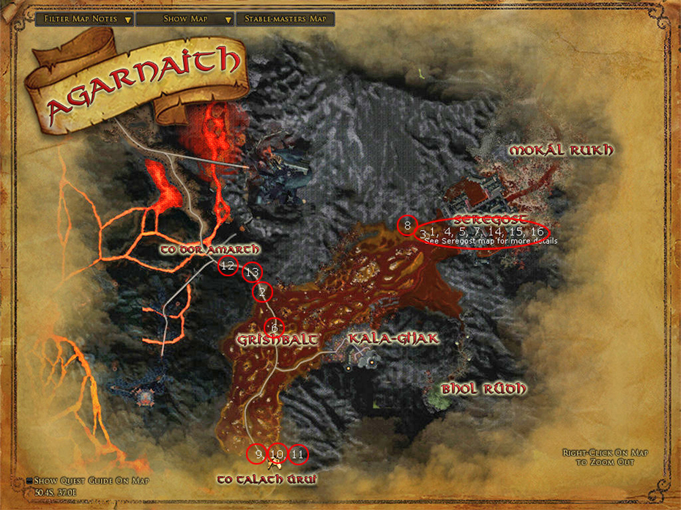

Lost Lore of Gorgoroth: Dor Amarth

https://lotro-wiki.com/index.php/Quest:Lost_Lore_of_Gorgoroth:_Dor_Amarth

- Shadowed page #1 ^{[48.2S, 17.3E]}
- Shadowed page #2 ^{[50.3S, 17.8E]} (adjacent to level 115 orc camp)
- Shadowed page #3 ^{[49.9S, 20.2E]}
- Shadowed page #4 ^{[44.1S, 16.1E]}
- Shadowed page #5 (inside Barad-dûr)
- Shadowed page #6 (inside Barad-dûr)
- Shadowed page #7 ^{[46.8S, 24.1E]}
- Shadowed page #8 ^{[47.2S, 26.0E]}
- Shadowed page #9 ^{[46.4S, 12.9E]} (deep in level 115 fell-spirit camp)
- Shadowed page #10 ^{[43.7S, 18.5E]}
- Shadowed page #11 ^{[43.3S, 20.9E]}
- Shadowed page #12 ^{[43.6S, 23.1E]}
- Shadowed page #13 ^{[52.1S, 10.4E]}
- Shadowed page #14 ^{[48.3S, 7.7E]}

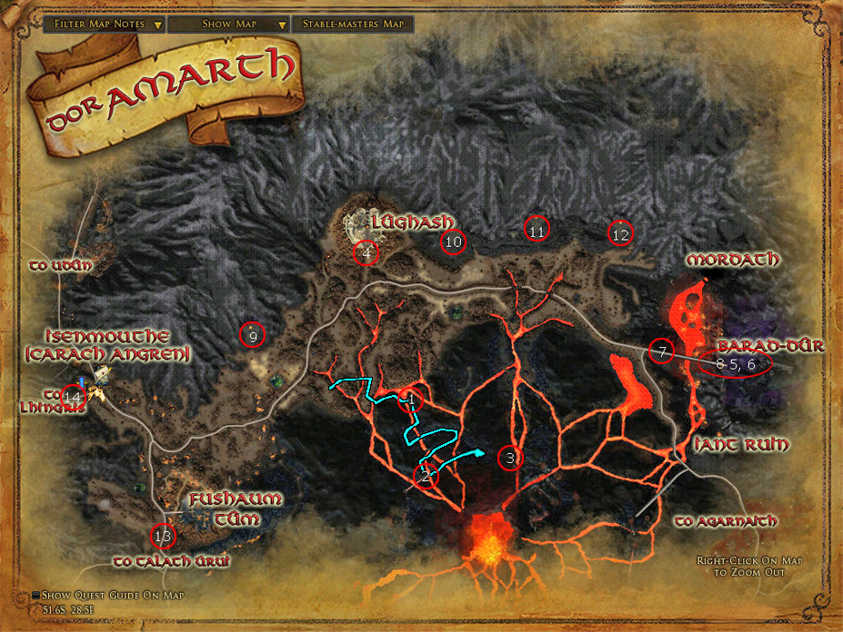

Lost Lore of Gorgoroth: Lhingris

https://lotro-wiki.com/index.php/Quest:Lost_Lore_of_Gorgoroth:_Lhingris
- Web-covered page #1 ^{[48.8S, 4.5E]}
- Web-covered page #2 ^{[58.0S, 4.6E]}
- Web-covered page #3 ^{[61.9S, 6.5E]} (in Torech Ungol)
- Web-covered page #4 ^{[60.3S, 8.2E]} (inside Cirith Ungol)
- Web-covered page #5 ^{[65.1S, 11.4E]}
- Web-covered page #6 ^{[16.8N, 33.0E]}(best reached from the entrance of Kâm Lagúrz at ^{[64.2S, 10.7E]} to avoid shadow)
- Web-covered page #7 ^{[16.5N, 31.4E]}(best reached from the entrance of Kâm Lagúrz at ^{[63.7S, 9.3E]} to avoid shadow)
- Web-covered page #8 ^{[56.4S, 5.1E]}
- Web-covered page #9 ^{[64.2S, 7.9E]}
- Web-covered page #10 ^{[61.8S, 11.6E]}
- Web-covered page #11 ^{[61.8S, 6.0E]} (in Torech Ungol)
- Web-covered page #12 ^{[53.7S, 7.5E]}
- Web-covered page #13 ^{[53.5S, 7.1E]}
- Web-covered page #14 ^{[53.8S, 5.1E]}
- Web-covered page #15 ^{[58.2S, 4.5E]}
- Web-covered page #16 (inside Cirith Ungol)
- Web-covered page #17 (inside Cirith Ungol)
- Web-covered page #18 (inside Cirith Ungol)
- Web-covered page #19 ^{[48.6S, 2.1E]} 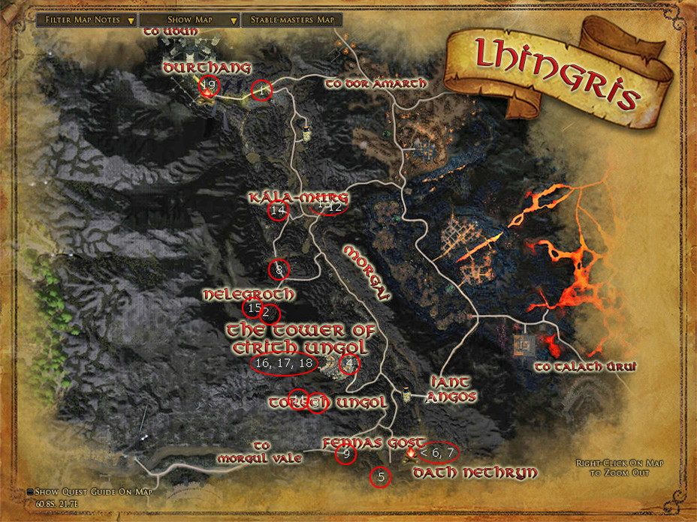

Lost Lore of Gorgoroth: Talath Úrui

https://lotro-wiki.com/index.php/Quest:Lost_Lore_of_Gorgoroth:_Talath_%C3%9Arui

- Singed page #1: ^{[58.8S, 12.1E]} (Dâr Mauzur)
- Singed page #2: ^{[63.7S, 21.3E]}
- Singed page #3: Inside Naerband
- Singed page #4: ^{[17.2N, 12.5E]} (Nargroth)
- Singed page #5: ^{[17.2N, 13.0E]} (Nargroth)
- Singed page #6: ^{[61.6S, 21.5E]}
- Singed page #7: Inside Naerband
- Singed page #8: ^{[17.1N, 13.6E]} (Nargroth)
- Singed page #9: ^{[58.4S, 23.8E]}
- Singed page #10: ^{[63.8S, 18.5E]}
- Singed page #11: Inside Naerband (bottom level of Torturer's room)
- Singed page #12: ^{[17.1N, 14.3E]} (in Nargroth, Strand of Fire)
- Singed page #13: ^{[61.7S, 21.1E]} (Magh Vadok)
- Singed page #14: ^{[61.2S, 25.0E]} (Magh Groth)
- Singed page #15: ^{[58.8S, 25.3E]} (Magh Nûl)

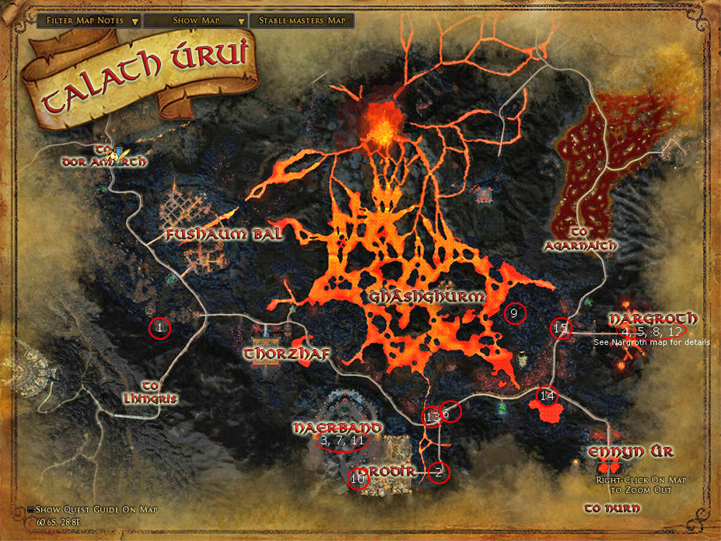

Lost Lore of Gorgoroth: Udûn

https://lotro-wiki.com/index.php/Quest:Lost_Lore_of_Gorgoroth:_Ud%C3%BBn

- Soot-smudged Page #1 ^{[42.6S, 2.0E]}
- Soot-smudged page #2 ^{[44.3S, 1.8E]}
- Soot-smudged page #3 ^{[42.9S, 3.1E]}
- Soot-smudged page #4 ^{[43.9S, 2.5E]}
- Soot-smudged page #5 ^{[41.3S, 3.3E]}
- Soot-smudged page #6 ^{[39.4S, 5.7E]} Inside Forges of Anglach
- Soot-smudged page #7 ^{[46.5S, 7.9E]}
- Soot-smudged page #8 ^{[41.8S, 5.89E]}
- Soot-smudged page #9 ^{[40.2S, 1.1W]}
- Soot-smudged page #10 ^{[46.4S, 1.3E]}
- Soot-smudged page #11 ^{[42.6S, 1.4E]} Inside Durthang
- Soot-smudged page #12 ^{[42.6S, 1.4E]} Inside Durthang
- Soot-smudged page #13 ^{[42.6S, 1.4E]} Inside Durthang (Tower Balcony)
- Soot-smudged page #14 ^{[44.5S, 1.1W]}
- Soot-smudged page #15 ^{[39.4S, 5.7E]} Inside Forges of Anglach
- Soot-smudged page #16 ^{[41.0S, 7.6E]}

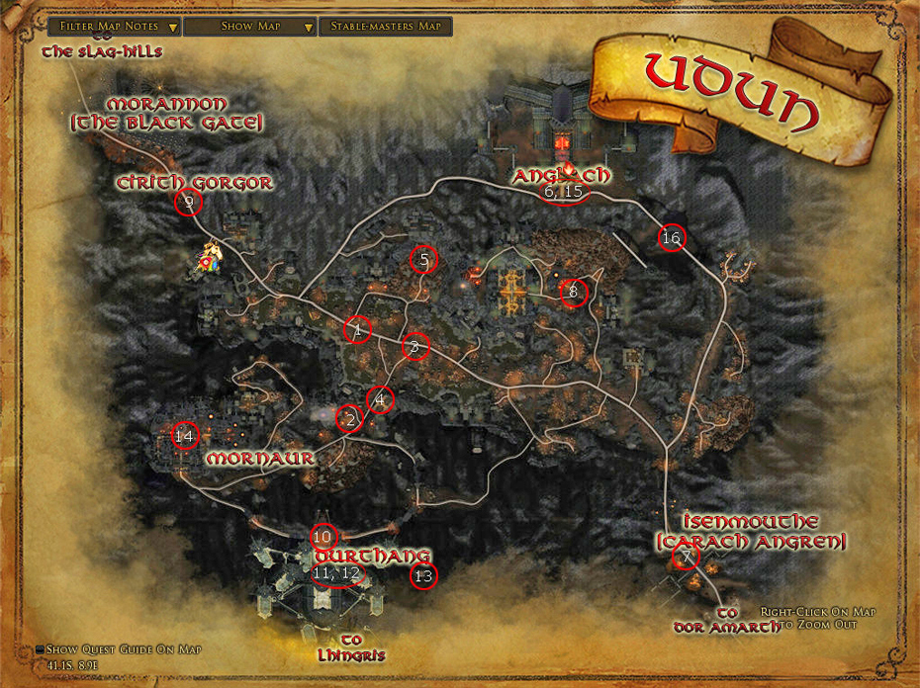

Lost Lore of the Vales: Old Mad Ubb
https://lotro-wiki.com/index.php/Quest:Lost_Lore_of_the_Vales:_Old_Mad_Ubb

Page 1 at ^{[0.7N, 60.6W]} (west of Sharkey's Slough)
Page 2 inside the Warrens of Tûn Melen, northern room (entrance at ^{[1.7S, 60.5W]})
Page 3 at ^{[12.0N, 63.4W]} (Goblin-gate)
Page 4 inside the Sorrow-well (entrance at ^{[7.0N, 55.9W]})
Page 5 at ^{[8.0N, 56.7W]} (The Old Ford)
Page 6 at ^{[1.4S, 55.5W]} (Blómgard, just north of the stable-master)
Page 7 at ^{[4.8N, 54.6W]} (Hultvís, south of the vendors)
Page 8 at ^{[4.8N, 54.1W]} (back of Hultvís, on the path to Ríkmar's house)
Page 9 inside Avabárg, hall off the eastern room (entrance at ^{[5.3N, 57.1W]})
Page 10 just inside the excavation at Tûn Melen (entrance at ^{[1.1S, 61.1W]})

Lost Lore of the Vales: Tauralindalë
https://lotro-wiki.com/index.php/Quest:Lost_Lore_of_the_Vales:_Tauralindal%C3%AB

Page 1 at ^{[2.9S, 53.6W]} (southern end of Côs Braen, inside the largest shelter)
Page 2 at ^{[0.7N, 53.1W]} (Rhosgobel, west of the pond, northern side of the bridge)
Page 3 at ^{[1.2S, 56.4W]} (along the road from Laerlad into Woodsedge)
Page 4 at ^{[5.3N, 57.2W]} (Avabárg)
Page 5 at ^{[10.9N, 56.3W]} (along the road from the Beorning-lands into Woodsedge)
Page 6 at ^{[8.1N, 55.4W]} (the fork going down to the Old Ford)
Page 7 at ^{[4.1N, 54.7W]} (Tríubad)
Page 8 at ^{[8.6N, 56.7W]} (on top of Hadhodiant, west end)
Page 9 at ^{[3.6S, 58.3W]} (the ford between Duskenvale and Laerlad)

